|  |  |
| --- | --- |
|  | ShredOs  By PilSo  5/9/2024 |

ShredOs is a disk eraser and can be used to Wipe using DOD.

Here is the link: or if it’s not on this you can find it by googling it.

<https://github.com/PartialVolume/shredos.x86_64?tab=readme-ov-file>

You can find the iso on my folder if not their maybe updates to it by looking at the ISO file or checking the website to see if there is a new version for it.

You need to use Rufus to do it, it should come in as default when it comes to configuration.

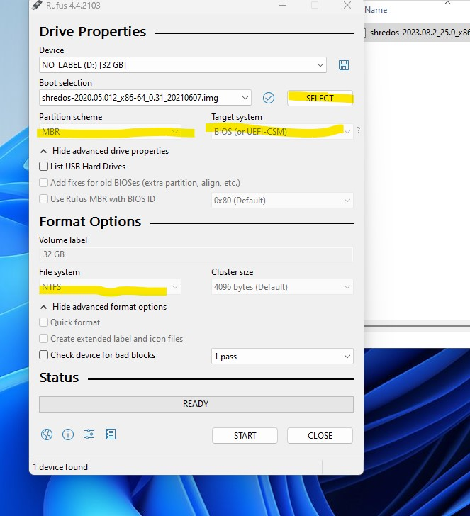

To use it you need to go into the Bios and make sure its ufi and make sure that the secure boot is off.

When you press f12 to boot make sure you choose ufei when you have the usb option.

You will see a ShredOs menu look like this

Make sure that the Method is DOD Short if not the bottom screen you should see direction press the m button to change it to that.

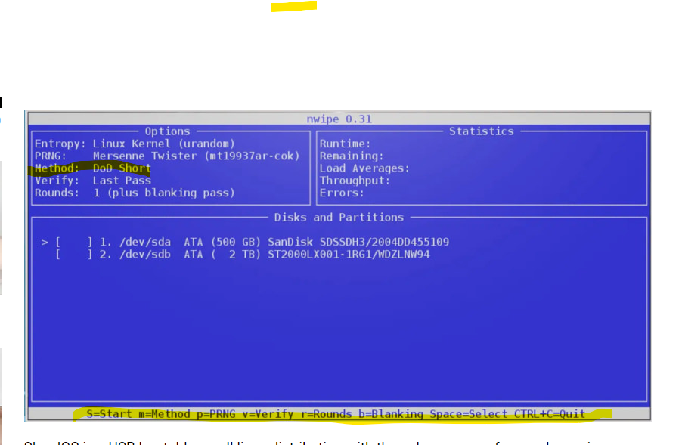

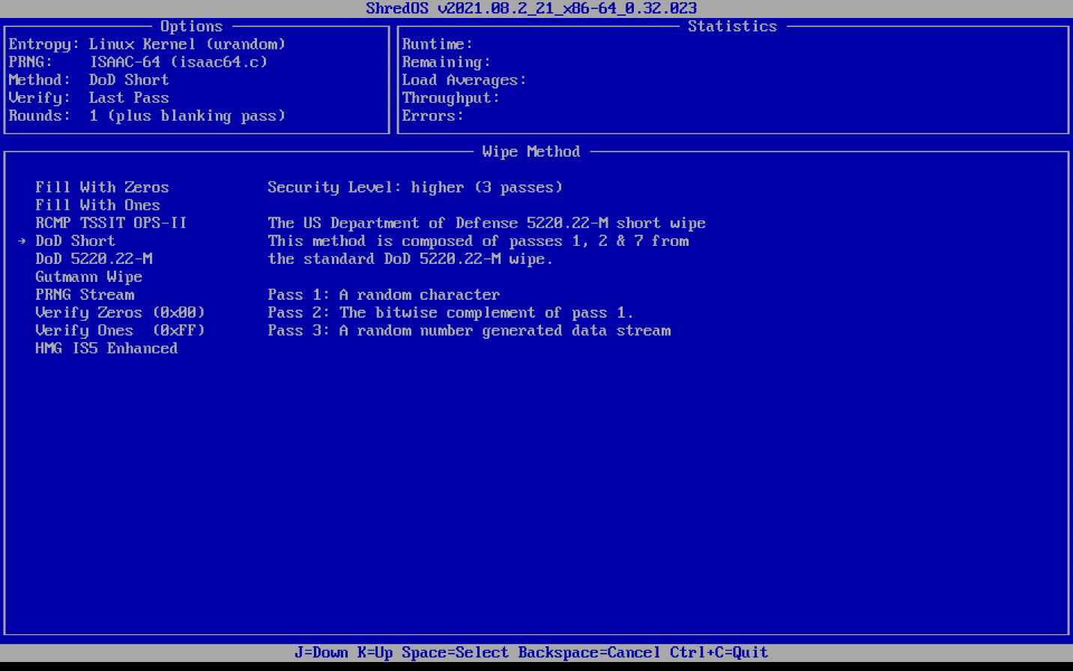

Also make sure you choose the correct file or your usb will be lost and must start over.

When you do hit space, and it would show the word Wipe when it does you can hit Capital S to start the process.

If you need more guidance look over the website for further instructions.

